**Livrabil Intermediar**

|  |
| --- |
| **Problem Statement or Product Vision** |

Our vision for the project is to create a social media app where people from all walks of life can connect by sharing posts and commenting on each other's content.

Targeted at both private users and businesses, the purpose of the app is to reach a wide audience.

Success will be tracked through user growth and interaction metrics.

The app will feature an easy-to-use interface for sharing and commenting on posts.

We want to be known for fostering a vibrant community of shared interests and lively discussion.

For now, our app is only available on the web, but we hope to expand to mobile in the future.

**Product features and functionalities**

Current features:

|  |  |  |  |
| --- | --- | --- | --- |
| **Feature** | **Description** | **Stakeholder** | **Alignment with Vision/Problem Statement** |
| User profile | Customize details, control settings | Users, Content Creators | Enhances user-centric experience |
| Login | Streamlined user access with a secure login process, ensuring quick and safe entry into the platform | Users | Facilitates seamless user interaction, aligning with our vision for user-friendly accessibility and addressing the need for secure, efficient login procedures |
| Register | Effortless onboarding through a user-friendly registration process, ensuring a smooth entry into the platform | New users | Facilitates a frictionless entry into our platform, aligning with our vision for inclusive accessibility and addressing the need for a straightforward registration process |
| Posts | Seamless creation and sharing of content, fostering user engagement and community interaction | Content creators, Users | Promotes dynamic user interaction, aligning with our vision for a content-driven community and addressing the need for a platform that encourages meaningful content creation and sharing |
| Comments | Enable discussions and feedback through a user-friendly commenting system, enhancing community interaction | Content creators, Users | Fosters an interactive community by facilitating meaningful discussions, aligning with our vision for a connected user base and addressing the need for a platform that encourages constructive conversations |
| Likes | Express appreciation for content with a simple and effective liking system, promoting positive engagement | Content creators, Users | Enhances user connection by promoting positive interactions, aligning with our vision for a supportive community and addressing the need for a platform that fosters a culture of appreciation and encouragement |

Delivery during this course:

|  |  |  |  |
| --- | --- | --- | --- |
| **Feature** | **Description** | **Stakeholder** | **Alignment with Vision/Problem Statement** |
| Pagination for Posts | Enable paginated display of posts | Users, Developers | Enhance user experience in navigating through posts |
| Preload Profiles | Load user profiles in advance for faster access | Users | Improve profile viewing efficiency |
| Aesthetic View | sort posts in descending order based on their posting time | Design Team, Users | Enhance user experience in navigating through posts |
| Conditional Post Display | The application selectively includes posts based on specific conditions | Users | Enhances engagement, personalised content, and optimises relevance for user satisfaction. |
| Follow-triggered Initial Feed Display | Show first three posts upon following a user | Users, Content Creators | Encourage user engagement and expedite content discovery |
| Private Profile | Allow users to set their profiles as private | Users | Empower users to control their privacy |
| Real time direct messages | Enable real-time one-to-one text messaging | Users | Facilitate instant communication between users |
| Restricted Messaging for Non-Followers | Limit Messaging to mutual followers | Users | Promote controlled and consent-based messaging experience |
| Admin dashboard | Allow admins to perform actions on behalf of other users | Admins | Helps with content moderation and customer support |
| Full screen chatting | Open chat interface in full-screen mode | Users | Enhance the user experience during chat interactions |
| Notifications | Implement real-time notifications | Users | Keep users informed about relevant activities |

Future releases:

|  |  |  |  |
| --- | --- | --- | --- |
| **Feature** | **Description** | **Stakeholder** | **Alignment with Vision/Problem Statement** |
| Categorizing Posts | Assign posts to categories for organization | Users, Developers | Enhance content organization for a better user experience |
| Post Recommendations Based on User Preferences | Recommend posts based on the user's preferred categories | Users, Developers | Personalize content delivery such that a user may stay for longer on our platform |

**Integration points**

1. **Push Notification Service:** Integration with a push notification service to send real-time notifications to users for activities such as likes, comments, and new followers.
2. **Real-time Messaging Service:** Integration with a real-time messaging service to facilitate instant messaging and chat features among users.

|  |
| --- |
| **Non-functional requirements** |

Non-functional requirements

Performance - Feed loading time

Specific: The feed should load in less than 2 seconds.

Measurable: The load time can be measured using performance tools such as Chrome DevTools.

Achievable: With optimized code and efficient server response time, this is achievable.

Realistic: Considering current technology, this is realistic.

Time-bound: This can be achieved within ~2 weeks.

Summary: Ensure the app's feed loads in under 2 seconds for 1000 users, as measured by Chrome DevTools, by optimizing code and server response.

Scalability - User load handling

Specific: The app should be able to handle 1000 users simultaneously without degradation in performance.

Measurable: The number of users can be measured using performance tools such as Google Analytics.

Achievable: With cloud-based solutions and proper server management, this can be achieved.

Realistic: Considering current services provided by cloud like AWS, this is totally realistic.

Time-bound: If the app is using cloud-based solutions, it can be easily scaled up within 1 week.

Summary: The app shall scale to handle 1000 users simultaneously without performance degradation, trackable through Google Analytics, leveraging cloud-based solutions and efficient server management, a realistic goal given current cloud capabilities.

Availability - Uptime

Specific: The app should have an uptime of 95%.

Measurable: Uptime can be monitored using tools like *Pingdom*.

Achievable: Can be achieved with robust infrastructure and good hosting services.

Realistic: It's a common target for most of the web apps.

Time-bound: Maintain this level of time each month.

Summary: Achieve and maintain an app uptime of 99% each month, as monitored by tools like Pingdom, through robust infrastructure and reliable hosting, a common standard for web apps.

|  |
| --- |
| **Customer Journey**  Inspired from [this blog](https://www.uxpin.com/studio/blog/persona-examples/#:~:text=In%20user%20experience%20and%20user,It%20helps%20with%20design%20iteration).  **User persona 1**  Name: Emily Smith  Age: 30  Occupation: Graphic Designer  Technology: iPhone 15  Goals:  - Discover new design trends and inspiration  - Connect with other designers and potential clients  - Share her work and get feedback  Behaviours:  - Scrolls through her feed during breaks  - Likes to keep her online presence professional  - Prefers easy-to-use interfaces  Frustrations:  - Overwhelmed by ads and non-relevant content  - Difficulty finding and connecting with other designers  **User persona 2**  Name: John Doe  Age: 20  Occupation: Student (Political Science)  Technology: Laptop  Goals:  - Stay up to date with current events  - Voice opinions and engage in political discussions  Behaviours:  - Frequently checks his feed throughout the day  - Follows influencers and organisations to stay informed  - Usually shares content that aligns with his political views  Frustrations:  - Encounters trolls and fake news  - Struggles to get his content seen by a wider audience  **Journey Map for Emily Smith**  Awareness  - Emily Smith hears about a new social media app from a friend  Consideration  - She visits the app's website to learn more about it  Acquisition  - She downloads the app and creates an account  Experience  - She starts by exploring her feed  - She uploads her first post  Engagement  - She receives a few like and comments, which encourages her to post more  - She interacts with other designers by commenting on their posts  - She connects with other designers and potential clients  Retention  - She discovers new design trends and inspiration |

|  |
| --- |
| **Activity Diagram or State Diagram** |

* Authenticate ([link](https://www.plantuml.com/plantuml/uml/7Own3e9044Jx_OefuHUW42iROsDbUO45De5Tuir5Fr-yzhsPv0sPwSsoRqBZfhWMhkgqCL55gXIRqTnZCSV7k28vz6kPvWlIE4PnNbhyRsXUcbi1kZhlHRUiQ1vHsTCMByS9VOBDqjq23Ep97BFgr4jc72B3wS-U7m00))  
  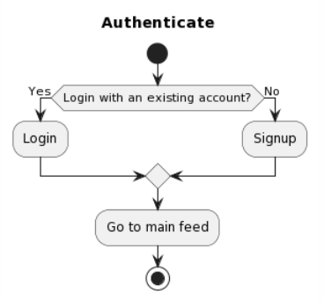
* Create a post ([link](https://www.plantuml.com/plantuml/uml/NP4_Rm8n3CLtVued9cxiUZT0rQ4RgYenT8mk9bWDSPGO-FgzS2cgcidMU_xvJ_RLNB7h9PA9HSPROMSCXwpLY1ug9JKcu5YvG2gYXi0UaeYJVsZZmTqaj49JR3gZ4JR8Bl149otV18oltiDpdOja4qsh01VS0WFkPucCxJ57TPuzd26oguONP9djMdWtj06s1nq803gslN6j-ZNMgHkU-6xxv8lU6DVUuv-Va-_G5lPvlhWEz5JaXEr7qPdPuovsnjpMbHHWvtNftT32r0k1ySz1ffQ_AqmVQJyFnyfzgyNjqinnQXtbHDKqqtw9bp_w0G00))  
  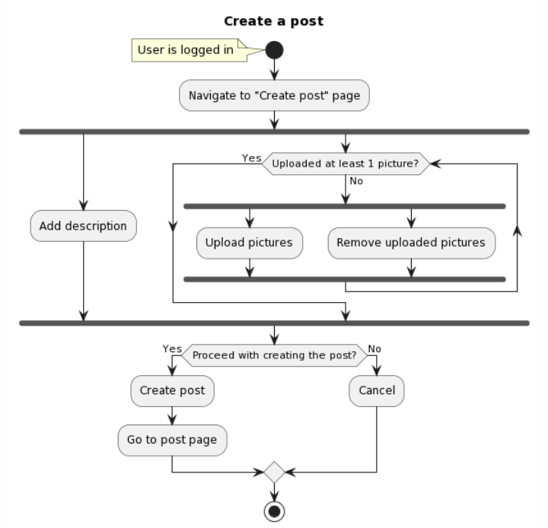
* Edit my profile ([link](https://www.plantuml.com/plantuml/uml/VL7HIWCn47pFLmnzklv2xw45wPDO1H7nCRrixXRkTakoRVNlpQM7AAWlsOMPdM4cksm-sNaQdR6DX7rWm_I1KzB88pbNSITgv82NJ0cSCMhVKm2B8maLsnpyXNjl15Ei7hu4LeX99uY_77rgtMOlHWbKNJHGwwv3OQ6v9pf1fI8i_NOzspHlbDSEo5UsRa3pEd0PaMaC4A8mIt3apXkhvErC1JgVYzvj1pOrq3bJ4ZzH-oVZV_J8-YjuDtZfQSbQ9dTsJZzq7csW1DyPgynd9E6MfkmSqJmjfvsAUPOCIabJNl8VT8qY8AwwFVjB8LRBtDwqEBhorWuhknJyplQztsnwShj2Ad_y2G00))  
  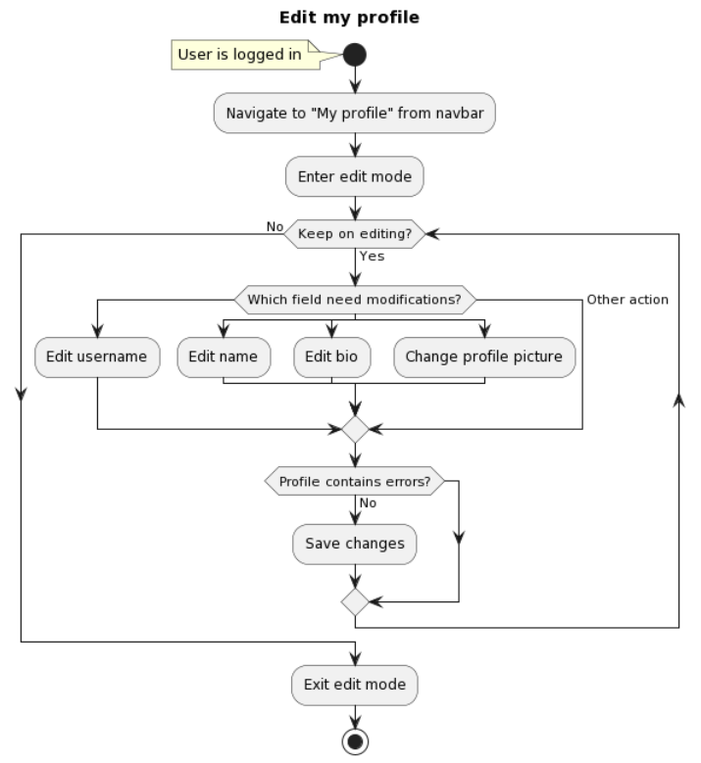

|  |  |
| --- | --- |
| * Delete my account ([link](https://www.plantuml.com/plantuml/uml/BOunheGm34HxdsB4CQ2X-B_SxVO0MMAGfSH6YK7YzciXMdlclPcxf-P7BUJYXV77XPrHBwHbiKETw4wGcZC1dyuDqb5ispX3b5Zp_HlVwPGjHTaDm-l2tcoLmWFMPXMQpczg4ut_we7WB8vgcUFoE1_X54BRQGvkpFe1)) | * Follow/Unfollow ([link](https://www.plantuml.com/plantuml/uml/DOwnJi0m34HtVyLjj1DxEr2MZjqwC4QA4ooPk4fS47zF5DJjwUvalwrvg7v_ARcuCdPJjP_NiwG1HAEdOiu4d8qhf44jPuwGGbpYw9OZV4iEpd13mDs7BmrNjIJAAqd2zAwLG_p5_sKf6VufRKpVvivSC7rmcmbOdlyhiJR6TDY8zoSiKL9Niukspbt_3m00)) |
|  |  |

**Functional Breakdown (**[**link**](https://www.figma.com/file/yV8wEZPoPMmQX6U067MB1G/IS---Functional-Breakdown?type=whiteboard&t=mkWBKodeOWloq0B8-6)**)**

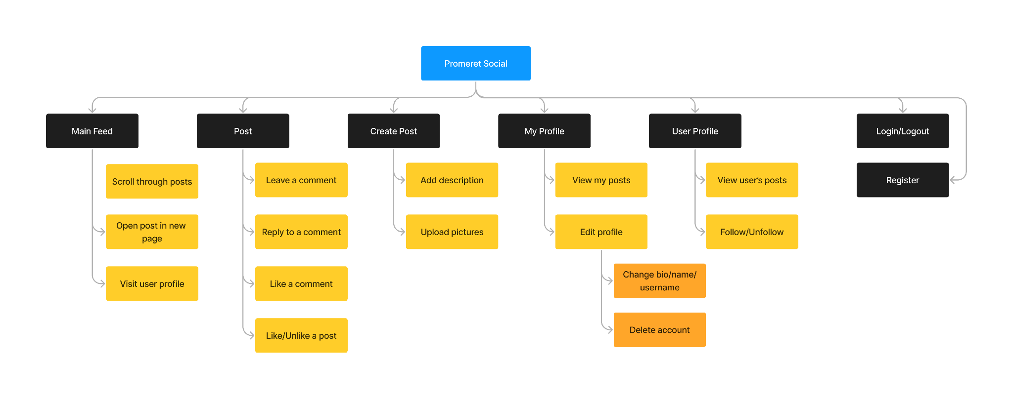

|  |
| --- |
| **A set of User Stories** |

1. As a creator, I want to make my profile private because only people I allow should be able to see the content I post.
2. As a regular user, I want to engage in real-time chat with other people because I need a quick way to share my thoughts about posts I see on my main feed.
3. As a creator, I want to receive notifications for likes, comments and follow requests because I need to be up to date with what other users are doing.
4. As a casual browser, I want to get content recommendations based on posts I liked previously because I do not like seeing content that is not interesting to me.
5. As an admin, I want to have a separate dashboard that allows me to easily perform actions on behalf of other users when it is needed.

Acceptance criteria

1. Feature: Private profile
   1. Scenario: Creator sets profile to private
   2. Given the creator is logged into their account
   3. When the creator navigates to the profile settings
   4. And the creator selects the option to make the profile private
   5. Then only approved users should be able to view the creator's profile
   6. And unauthorized users should see a privacy notice
   7. Scenario: Creator allows specific users to view the private profile
   8. Given the creator has a private profile
   9. When the creator accepts follow requests from specific users
   10. Then the added users should be able to interact with the creator
   11. And other unauthorized users should still see a privacy notice
2. Feature: Real-time Chat
   1. Scenario: Regular user initiates real-time chat
   2. Given the regular user is logged into their account
   3. And the regular user is on another user’s profile page
   4. When the user initiates a real-time chat with the desired user
   5. Then the chat interface should open
   6. And the user should be able to send and receive messages in real-time
3. Feature: Notification System
   1. Scenario: Creator receives notifications
   2. Given the creator is logged into their account
   3. When the creator receives likes, comments, and follow requests
   4. Then the creator should receive real-time notifications
   5. And the notifications should be visible in the notification center
4. Feature: Content Recommendations
   1. Scenario: Casual browser receives content recommendations
   2. Given the casual browser is logged into their account
   3. And the casual browser has liked posts previously
   4. When the casual browser navigates to the main feed
   5. Then the casual browser should see content recommendations based on their liked posts
   6. And the recommended content should align with the user's interests
5. Feature: Admin Dashboard
   1. Scenario: Admin accesses the separate dashboard
   2. Given the admin is logged into their admin account
   3. When the admin navigates to the admin dashboard
   4. Then the admin should have access to a separate dashboard with admin functionalities
   5. And the admin should be able to perform actions on behalf of other users